**Welcome to Ripponden Junior and**

**Infants School**



**A guide for Parents and Carers of Children Starting Reception in**

**2022/2023**

**Welcome to Ripponden Junior and Infants School!**

**We very much want you to feel part of the Ripponden family as quickly as possible so we will be welcoming and supporting you in many ways over the coming weeks.**

**This booklet has been written to help prepare you and your child as you join our school. We aim to give you all of the essential information that you need to ensure that your child has a really happy, positive start to school and goes on to have a successful education.**

**At Ripponden Junior and Infants School we recognise that parents and carers are a child’s first and most enduring educators. We aim to foster and nurture the relationship between school and home and establish trusting, supportive and meaningful communication.**

**If, after reading this booklet, you have any further questions, then please do not hesitate to contact the team via the email address below:**

[**office@ripponden.calderdale.sch.uk**](mailto:office@ripponden.calderdale.sch.uk)



**We look forward to welcoming you to our school community.**

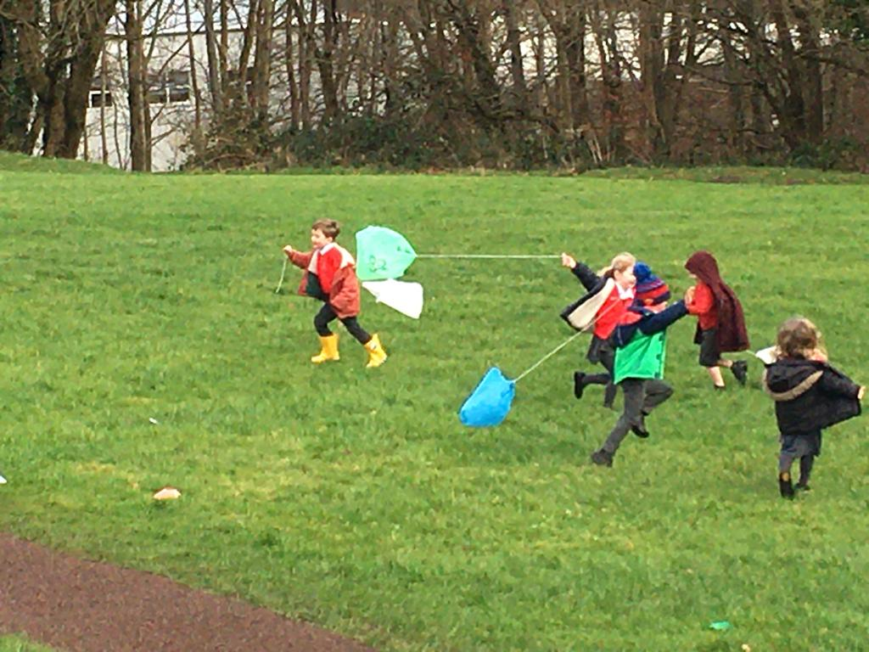

**Staff in Little Acorns**



**Please feel free to communicate with us at the beginning or end of the day or send an email to the office if you need to pass a message on. Other adults will occasionally work in Little Acorns, but these are main ones.**

**Key Leaders in School**

**  **

Mrs A Whiteley

Cover Supervisor

Mrs J Kenny

Little Acorns’ Teacher

and

Assistant Headteacher

Mrs L Greenwood

Little Acorns’ Teaching Assistant

Ms M Gilmartin

Saplings (Y1) Teacher

SENDCo

Mrs J Lomas

Redwoods (Y6) Teacher

Assistant Headteacher

Mrs L Bamforth

Headteacher



**The School Day**

**The school day starts at 8.45am for EYFS, when the gates will be opened and the children will be welcomed into the unit. Drop off times are slightly staggered from the rest of the school so that we have time to handover and settle the children. If children arrive after the gates have closed, then please report to the office so that your child can receive their mark and be taken to class. The school day ends at 3.10pm and we will have the children ready to be collected from the gates.**

**Attendance**

**It is very important that children attend school every day, so that they can make good progress in their learning. It is very tricky for children when they miss days of school and exciting experiences with their friendship groups and then have to catch up on their learning.**

**If your child is unwell and has to be absent from school, it is your responsibility to contact the school office that morning to inform us of the reason for their absence that day. If we do not hear from you, then we will chase this up and this may involve seeking advice from the Educational Welfare Team at Calderdale. This is to ensure the safety of all our children, which I am sure you will understand.**

**School Dinners**

**Children in Reception to Year 2 are entitled to free school lunches, regardless of family circumstances. Our lovely dinners are made in our own school kitchen and the children really enjoy them. If your child has any allergies or dietary requirements, then please let us know. If you would prefer to send a packed lunch from home, then that is fine too. We will make sure that the children still sit together with their friends to enjoy the social aspect of dining.**

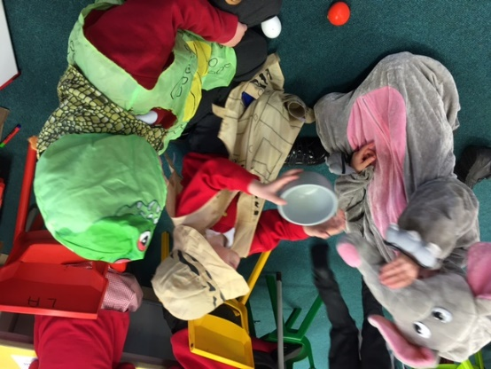 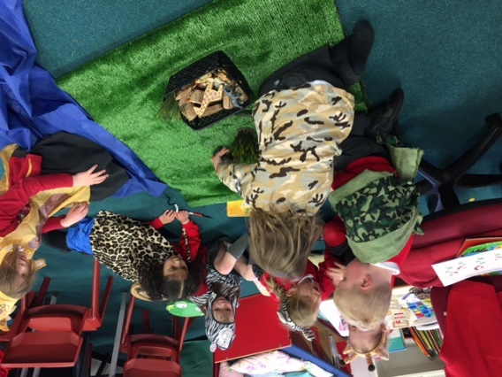

**A Day in Reception**

**In Little Acorns, we understand the importance of play and how vital it is to have opportunities for exploring, creativity and being active throughout the school day. We know that creating enabling environments, building positive relationships and understanding that every child is unique, are all key for encouraging children’s learning and development.**

**In our approach to teaching, we use a range of strategies that encourage the skills required for our pupils to become life-long learners. The characteristics of effective learning are promoted continually with a focus on positive attitudes, effort and the process of learning – not just the end result. Our day consists of a balance of child initiated learning and teacher directed time.**

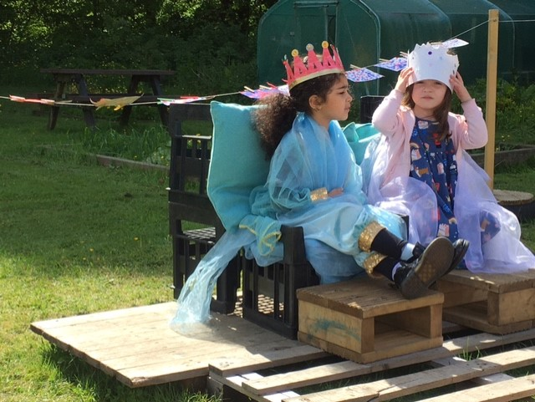

**Child Initiated Learning**

**Children can choose to learn through play either indoors or outdoors throughout each day. The environment and provision largely remain the same but are enhanced to meet children’s needs and interests throughout the year. The Little Acorns staff promote and facilitate learning opportunities during this time and as they play with and observe the children they support and extend their learning. Doing this allows us to learn so much about your child’s interests and ideas which gives us insight into their thinking, development and how they learn best. This enables us to plan individualized next steps of learning with the children as co-constructors of their own learning journeys and environments.**

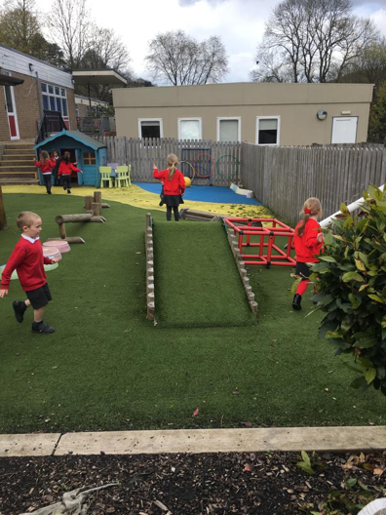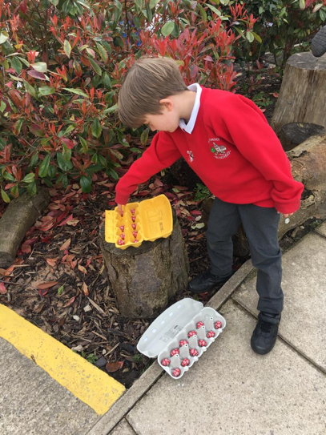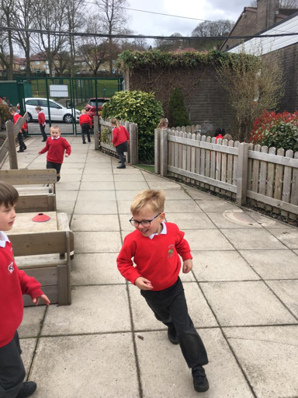

**Adult Directed Time**

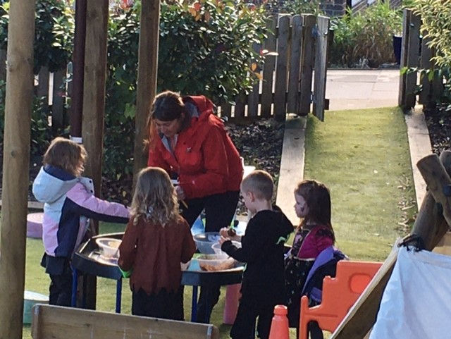

**Adult directed time ensures that all children fully access the Foundation Stage curriculum. This might happen as a whole class, or in a small group or 1 to 1. It gives staff time to identify differing needs within the class – such as those that require additional challenge or support in a particular area and to cater for their needs and abilities. These sessions are usually short and focused and are re-visited through play based activities in the provision. There are daily whole class teaching sessions in specific skills for phonics, English and mathematics.**

**Mastery in Mathematics**

**Teaching for Mastery in mathematics means supporting all pupils to gain a deep, secure and long-term understanding of maths. We teach maths by breaking down objectives into very small steps, so that every pupil is secure in a new concept before moving on. We focus upon teaching for fluency, reasoning and problem solving. We continually revisit maths facts as we know that becoming fluent in maths facts allows our brains to concentrate on higher level skills. We follow the White Rose Maths scheme.**





**Phonics**

**Phonics are units of sound which are represented by graphemes when written down. We teach children all the different sounds (phonemes) in a systematic way and teach them some of the ways to represent each sound. This is incremental and builds up over the year and continues well into KS1. Alongside teaching phonemes we also explore environmental sounds and musical instruments, rhythm and rhyme which all help the children to listen carefully and identify sounds around them.**

**In order to teach phonics effectively, we follow the Little Wandle Revised Letters and Sounds systematic synthetic phonics scheme. A parents’ workshop will be held in school early in the first half term to explain this further and we would encourage you to attend this event if you can. In September your children may know some of their sounds, or none at all, or may even be using their phonics to help them read and write. Whatever their starting point, our priority is to support your child in developing phonic awareness on their journey to becoming early readers. We start this journey as soon as we can and aim for phonics teaching to begin in the second week of the new school year.**

**Your child will bring a phonics book home with new phonemes and graphemes and you can support your child’s learning by helping to practice these at home.**

**Reading**

**Reading and stories are at the heart of everything we do in Little Acorns. We read every day either to or with each child (and often both). Your child will begin by bringing home books without words. You can help by sitting down somewhere quiet and showing your child how to look carefully at the pictures in the right order. There are also many things you could discuss such as describing the story in their own words, predicting how characters may feel and what may happen next. Once your child is able to apply some of their phonic knowledge, they will bring home books matched to their phonics level to further develop their skill and understanding. These will be fiction and non-fiction books and they will be changed every week. They can also choose a library book every week for sharing at home.**

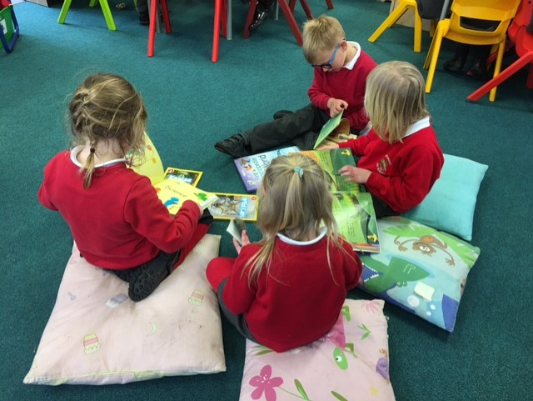

**Outdoor Learning**

**Children and staff are incredibly passionate about learning outdoors and the sense of wonderment it provides. Learning outdoors is a stimulating and engaging experience which inspires confidence, social skills, motivation and perseverance. Our aim is to get outside whatever the weather! We provide waterproof trousers and jackets and we ask that you send a pair of wellies to be kept at school for outdoor experiences. Please also be mindful of the weather and provide warm coats, hats, scarves, gloves, sun hats and sun cream (all labelled please!) as appropriate.**

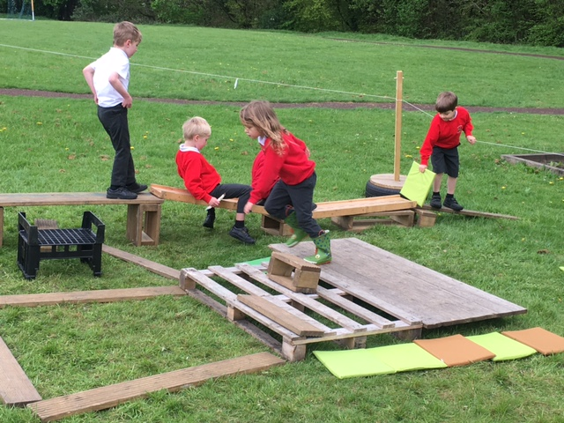

**Behaviour for Learning**

**We believe that the most effective and efficient learning is achieved in a happy and calm environment. In order to develop and foster such an atmosphere, we will be positive and consistent with all children. Our Branch Out Basics underpins everything we do in school, so everyone knows what is expected of them.**

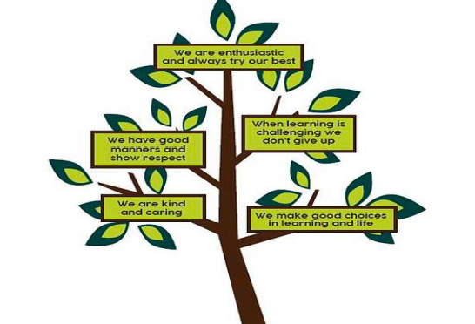

**Things you will need ready for school**

**Please make sure all items of clothing and footwear are clearly labelled with your child’s name.**

**School Uniform**

* **School jumper or cardigan, either with the logo or plain red**
* **School white polo shirt with a logo or plain white**
* **Grey trousers or skirt**
* **Shorts or red gingham dresses may be worn in warm weather**
* **Black sensible shoes**
* **White, black or grey socks or tights**

**PE Kit**

* **School red polo shirt with logo or plain red**
* **Black shorts**
* **Pair of trainers**
* **Winter: black leggings or joggers and a red hoodie**

**Bags**

* **School book bag (no big rucksacks please – book bags make life easier for storing in class and for staff to change reading books or put to information in.)**
* **Red drawstring PE bag**

**Other**

**A named carrier bag with one spare outfit (non-uniform) including pants and socks to hang on their peg in case of accidents.**

**A pair of wellies to be kept in school.**

**It is really important that children come to school in the correct uniform. Not only do they look smart, it gives the impression that children are ready to learn and we are all part of the Ripponden Family.**

**In terms of shoes – please make sure that children can fasten them themselves. Velcro makes it much easier than laces (especially for the staff, if they have to go round 30 children with laces, if they can’t do them themselves!)**

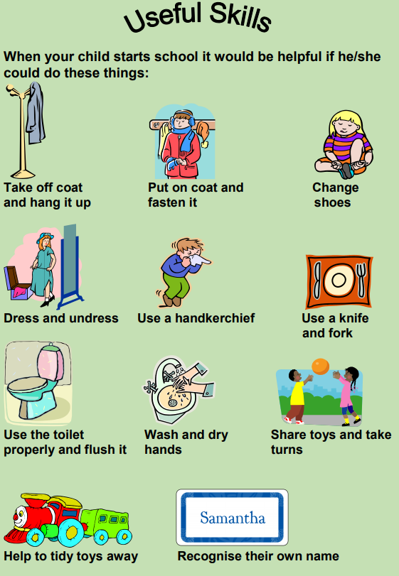

**How you can help at home**

**Playing with sounds**

**Singing songs and nursery rhymes enables children to internalise patterns of language. Books and stories which play with words and rhymes will help children to discriminate between sounds, an important skill for reading and writing. Children love listening to these sounds and rhymes. Repeated words and phrases can encourage children to join in. Children who have heard a lot of story language will start to use it in their play and in their writing once they start to write their own stories. We will offer parents a learning session about this in the autumn term. In the meantime, you can check out a useful website with lots of ideas to help at home and free e-books and activities** [**https://www.oxfordowl.co.uk/**](https://www.oxfordowl.co.uk/)

**Joining the library**

**Public libraries have many wonderful books for young children and always welcome young members for free. Children have their own library ticket and borrow picture books, story books, information books and CDs. Libraries often have a free story time and special events. Joining a library early in a child’s life can make a real difference to their later learning.**

**Everyday maths**

**Maths is all around us and you can do so many activities each day that will help promote your child’s understanding in this area. Here are some ideas:**

* **Point to numbers in the home, on doors, in shops, car registrations etc.**
* **Ask your child to count out sets of items, for example, how many cups do we need to set the table? You can have 5 chocolates, count them out etc.**
* **Let your child help you sort out the washed socks and pair them up.**
* **Tell your child the days of the week, months and seasons.**
* **Sing number rhymes with your child, e.g. 5 little ducks, 10 fat sausages.**
* **Look for patterns in the environment and talk about them.**
* **Point out different colours and shapes.**
* **Talk about capacity and weight with simple mathematical language, such as full, empty, half full, heavy, light, heavier, lighter, more, less.**
* **Use the language of time – before, after, next, later, yesterday, tomorrow, last week, 4 o’clock, afternoon etc.**

**Making a Mark**

**The process of learning to write is a gradual one which takes a lot of effort and concentration. Before they can even begin children need to have acquired sufficient strength in their large muscles through lots of physical activity like playing outdoors, riding bikes and scooters, pouring and tipping, messy play, skipping, climbing and swinging. This works different muscle groups and develops core strength which is vital for posture and stamina. After developing strong gross motor skills, they can develop further by refining fine motor skills, working the muscles in their fingers through activities such as playdough, threading beads and cutting with scissors, as well as holding a pencil drawing and colouring.**

**You can try these at home:**

* **Listening when they explain what their writing says and if they want, you can scribe their message next to their own writing.**
* **Drawing attention to letters and words all around them, e.g. mail through the door, letters and words in the environment, in books, on the television.**
* **Letting your child watch you writing; reading what you have written to them and telling them who the letters and messages are intended for.**
* **Encouraging them to add their own writing to your letters, cards, or make their own labels for toys, possessions and friends.**
* **Making an alphabet scrap book or a book about anything at all.**

**We know that the pandemic may still be affecting families in our community in many different ways. There are still the day-to-day concerns about infection and health plus the yet unknown impact of the lengthy lockdown periods we all endured. Our priority is that everyone in our school family is safe and well and that your children are supported to cope emotionally during this time of transition. We will do all we can to make the transition as smooth as possible and support them to enjoy attending school and socialising every day. We know that children grow and change at different rates and therefore so does learning and development. Our provision will cater for your child’s individual needs and enable them to flourish and make super progress as part of the Ripponden family.**

**We look forward to meeting you all soon!**

