Ripponden J&I School
Year 5 Weekly Learning – W/C 4th May 2020

This timetable gives an overview of home learning activities, as set by your teacher. In addition to this, teachers in Key Stage Two will continue to email daily with updates and ideas and teachers in Key Stage 1 and Reception will be emailing every couple of days. These email messages will continue to go to children in KS2 and to their parents in R/KS1 and they will be put on the class pages of the website. The message is, as always, to do what you can – there is no pressure from school – but we are here if you need help.

 | Monday  4th May | Tuesday  5th May | Wednesday  6th May | Thursday  7th May | Friday 8th  Bank Holiday
PE | Real PE  Joe Wicks  Cosmic Kids Yoga | Real PE  Joe Wicks  Cosmic Kids Yoga | Real PE  Joe Wicks  Cosmic Kids Yoga | Real PE  Joe Wicks  Cosmic Kids Yoga
Reading | 20 minutes daily – can be your own reading book and there are free audio books on Audible available now. You have also been assigned books on Bug Club (active learn login details). | 20 minutes daily – can be your own reading book and there are free audio books on Audible available now. You have also been assigned books on Bug Club (active learn login details). | 20 minutes daily – can be your own reading book and there are free audio books on Audible available now. You have also been assigned books on Bug Club (active learn login details). | 20 minutes daily – can be your own reading book and there are free audio books on Audible available now. You have also been assigned books on Bug Club (active learn login details).
SPAG/ Spelling | ‘ough’  Word search  (see below) | Spelling shed – stages 5 & 6 (online spelling practice) | ‘ough’  Activites below | Spelling shed – stages 5 & 6 (online spelling practice)
Maths | Hamilton Trust – Home Learning (link below)  Week 5 – Day 1  +/- numbers with 2 decimal places | Hamilton Trust – Home Learning (link below)  Week 5 – Day 2  Add and estimate decimals | Hamilton Trust – Home Learning (link below)  Week 5 – Day 3  Subtract numbers with one decimal place | Online maths and finishing work from days 1-3
English | VE Day activities  (see below) | VE Day activities  (see below) | VE Day activities  (see below) | VE Day activities  (see below)
Art | Woodland Trust’s Green Tree School’s Award: Find A View (see Ms Gilmartin’s message below).  Also, Mrs Bamforth sent out details of a design competiton – have a go if you fancy it! https://www.designglass.co.uk/competitions

If you do not have a printer at home, then please don’t worry - you can still complete the activities on a piece of paper or in a notebook.

GENERAL LINKS
PE Links:

Real PE: https://home.jasmineactive.com/login
login: parent@rippondenj-1.com password: rippondenj – Scroll down and click on the pink KS2 button and follow the activities for each day.

https://www.youtube.com/user/thebodycoach1

https://www.youtube.com/user/CosmicKidsYoga

www.gonoodle.com

General Links:

www.twinkl.co.uk/offer NB: Parents if you haven’t already, you will need to create a free Twinkl account using the offer code CVDTWINKLHELPS

https://classroomsecrets.co.uk/free-home-learning-packs

https://www.activelearnprimary.co.uk/

English Links:

www.spellingshed.com

https://home.oxfordowl.co.uk/for-home/

Maths Links:

https://www.hamilton-trust.org.uk/documents/27101/Maths_Y5_Week_5.zip

www.Sumdog.com

www.mathshed.com

https://ttrockstars.com

www.whiterosemaths.com
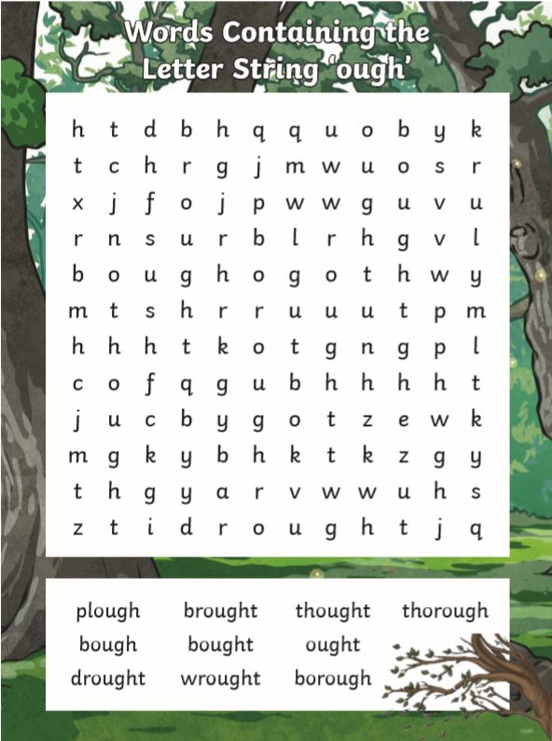
You could practise these words by:

- Rainbow writing
- Pyramid writing
- Write dictation sentences
- Make a crossword or your own word search.
VE Day – UKS2
The project this week aims to provide opportunities for you to learn more about the area you live in.
Choose one or more a day to explore. Be creative about how you present your work.
Understanding World War Two  On 8 May 1945 Britain celebrated the end of World War Two. To understand why VE Day was so important, you need to understand WW2. Research what happened during WW2. When did it start? Why did it start? Who fought? Where did fighting take place? What happened during the Battle of Britain? What happened on D-Day? What was rationing? What was evacuation? What happened during the Blitz? You may present this information in any way you choose.  https://www.bbc.co.uk/bitesize/guides/z9s9q6f/revision/1 | Plan your own street party  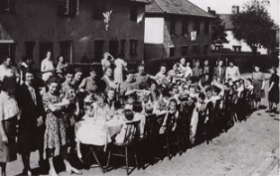  On 8 May 1945, Britain began to rejoice. People ran out onto the streets, church bells rang, bunting and banners were hung up and people brought food to eat at street parties. Plan your own street party. Where would it be? What games would be played? What decorations would be put up? What food would be eaten? | 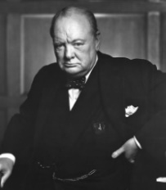  Research Winston Churchill  Winston Churchill was the Prime Minister in 1945. Research and make a fact file about who Churchill was. Consider why he was important, his personality, his family, his hobbies and his jobs.
Postcard task  Write a ‘Postcard from the Past’. Imagine you were at the first VE day and heard the news that the war had ended.  What might you tell your family about what you heard? What did you do? What did you eat? Who else was there? What games did you play? What decorations were made and hung up? Use the link below find out more about VE Day  https://www.bbc.co.uk/teach/class-clips-video/history-ks2-ve-day/z7xtmfr  https://www.bbc.co.uk/teach/ve-day-How-did-the-british-plan-to-celebrate/zndn7nb | Flag task  During World War Two, countries that were part of the British Empire fought alongside the British. Some of these countries were: Canada, USA, Bermuda, Jamaica, The Bahamas, Australia, New Zealand, Kenya, Mauritius, Seychelles, Trinidad and Tobago, India and Cyprus. Find and draw the flags for these countries. Can you find other countries that fought alongside the British in WW2 and find and their flags too? | Design your own VE coin or medal  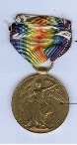  8 May 1945, now known as VE Day, saw the beginning of the end of the Second World War – the conflict that claimed the lives of millions and reshaped the future of countries and continents. The Royal Mint have designed a commemorative coin to remember VE Day. Your task is to design your own commemorative coin or a VE Day medal. You could think about the following ideas when designing yours: the years of the war; the colours of the ally flags or a reference to how the war was fought (land, air and sea).
Remembering VE Day  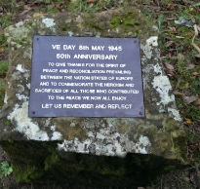  There are many memorials plaques for VE Day. This one says “VE Day 8 May 1945 50th anniversary. To give thanks for the spirit of peace and reconciliation prevailing between the nation states of Europe and to commemorate the heroism and sacrifices of all those who contributed to the peace we now all enjoy. Let us remember and reflect”. Now we are celebrating the 75th anniversary, design your own memorial plaque and write your own message on your plaque. | Music  To link with VE day we are going to discover some music from the 1930s and 40s. · Listen to the song ‘In the Mood’ and make a list of the instruments that are playing in the Big Band.  - Can you name the most famous Big Band of that time?  - What do you notice they do when it is their turn to play the solo section?  - Research some other songs from this era and make a list. | VE reflections  Now you know more about VE Day, answer these questions to sum up your learning on VE Day.  - Why do you think it is important to celebrate and recognise VE Day?  - How do you think VE Day should be celebrated in the future?

Hello everyone!

Here is our next whole school activity to gain more points for the Woodland Trust’s Green Tree School’s Award. We already have gold, let’s carry on going for platinum!! The Woodland Reps have already made a start on this activity, let’s see if more of us can create some lovely art work for our Woodland Display in school and gain more points on the way to the platinum award.

Find A View - 5 points for the Green Tree School Award

Task 1. Practise taking photos of nature from different viewpoints in your garden or near home. Learn how to use the zoom function! Fill in the pre-visit chart and think about what you are photographing, and from what viewpoint.
Task 2. Prepare your viewfinder and look at the examples of the nature photos. You are now ready to take photos on your walk. What different viewpoints will you use?
Task 3. Choose your favourite view and create your own artwork based on the photograph.

Post your photographs of your art on Facebook, and also send them to the office so that I can submit them to the Woodland Trust.

I can’t wait to see your Find A View art work!

Kind regards,

Ms. Gilmartin

