Ripponden J&I School
Year 5 Weekly Learning – W/C 27th April 2020

This timetable gives an overview of home learning activities, as set by your teacher. In addition to this, teachers in Key Stage Two will continue to email daily with updates and ideas and teachers in Key Stage 1 and Reception will be emailing every couple of days. These email messages will continue to go to children in KS2 and to their parents in R/KS1 and they will be put on the class pages of the website. The message is, as always, to do what you can – there is no pressure from school – but we are here if you need help.

 | Monday  27th April | Tuesday  28th April | Wednesday  29th April | Thursday  30th April | Friday  1st May
PE | Real PE  Joe Wicks  Cosmic Kids Yoga | Real PE  Joe Wicks  Cosmic Kids Yoga | Real PE  Joe Wicks  Cosmic Kids Yoga | Real PE  Joe Wicks  Cosmic Kids Yoga | Real PE  Joe Wicks  Cosmic Kids Yoga
Reading | Listen to the first chapter of the Twinkl e-book “How to Skin a Bear”  https://www.youtube.com/watch?v=l84_2UGoIbA&feature=youtu.be  Then follow the link to answer the retrieval comprehension questions | Listen to the 2nd chapter of the Twinkl e-book “How to Skin a Bear”  https://www.youtube.com/watch?v=tViltpvMhgA&feature=youtu.be  Then follow the link to answer the summarise comprehension questions | Listen to the 3rd chapter of the Twinkl e-book “How to Skin a Bear”  https://www.youtube.com/watch?v=JkzHJpkS5cM&feature=youtu.be  Then follow the link to answer the vocabulary comprehension questions | Listen to the 4th chapter of the Twinkl e-book “How to Skin a Bear”  https://www.youtube.com/watch?v=APjbg5kVIZk&feature=youtu.be  Then follow the link to answer the explain comprehension questions | Listen to the 5th chapter of the Twinkl e-book “How to Skin a Bear”  https://www.youtube.com/watch?v=Gp4DWoj6nYk&feature=youtu.be  Then follow the link to answer the inference comprehension questions
SPAG/ Spelling | Spelling shed – stages 5 & 6 (online spelling practice) | Mr Whoops’ spelling mistakes 1 – practising Y5/6 words  (see resources below links) | Spelling shed – stages 5 & 6 (online spelling practice) | Mr Whoops’ spelling mistakes 2 – practising Y5/6 words  (see resources below links) | Spelling shed – stages 5 & 6 (online spelling practice)
Maths | Hamilton Trust – Home Learning  Week 4 – Day 1  Use column addition to add 4 and 5 digit numbers  https://www.hamilton-trust.org.uk/documents/27036/Maths_Y5_Week_4.zip | Hamilton Trust – Home Learning  Week 4 – Day 2  Column subtraction | Hamilton Trust – Home Learning  Week 4 – Day 3  Use column subtraction to solve word problems | Hamilton Trust – Home Learning  Week 4 – Day 4  Calculate negative numbers in the context of temperature | Hamilton Trust – Home Learning  Week 4 – Day 5  Calculate negative numbers in the context of temperature
English  There is no need to actually print out the resources, as you can use a notebook/lined paper to record your work. | Hamilton Trust Home Learning  Week 4 – Day 1  https://www.hamilton-trust.org.uk/documents/27027/English_Y5_Week_4.zip  Read the Superhero poem and practise writing sentences with relative clauses. | Hamilton Trust Home Learning  Week 4 – Day 2  Prepare a performance of the Superhero poem. Practise finding relative clauses and write a new Superhero poem with relative clauses in it | Hamilton Trust Home Learning  Week 4 – Day 3  Read a range of persuasive texts and identify the features. | Hamilton Trust Home Learning  Week 4 – Day 4  Watch a range of adverts and identify the difference between fact and opinion. Write your own advert. | Hamilton Trust Home Learning  Read a letter and highlight the persuasive features. Write a persuasive paragraph and prepare a talk.
Topic | PSHE  NB Parents may wish to read the following guidance before going ahead with these sessions https://www.pshe-association.org.uk/system/files/Guide%20for%20parents%20and%20carers%20educating%20children%20at%20home.pdf  - Mental Health: Keeping well and managing feelings A really good power point with some activities on the importance of looking after our mental health (especially at this time) and everyday behaviours which can help our mental health.  https://www.pshe-association.org.uk/system/files/Primary%20 %20Mental%20Health%20home%20learning%20lessons%20%26%20resources.zip  - Looking after your wellbeing A power point and resources to help you think further about your own wellbeing including positive thinking and self-kindness  https://www.twinkl.co.uk/download/6311871  - Thinking Positively Another good power point with some follow up activities about mindfulness  https://www.twinkl.co.uk/download/6308575  - The importance of teamwork A great lesson from BBC Bitesize about the importance and benefits of working as a team  https://www.bbc.co.uk/bitesize/articles/zdq3bdm  This is your PSHE work for the whole week so take your time with it – you could produce a booklet, video or photo story to show what you have learnt. (If you have an iphone or an ipad that you can use, you could try an app called imovie maker. If you are using android devices (Samsung etc) then search your app store for a movie maker or video editing app.)

If you do not have a printer at home, then please don’t worry - you can still complete the activities on a piece of paper or in a notebook.

GENERAL LINKS
PE Links:

Real PE: https://home.jasmineactive.com/login
login: parent@rippondenj-1.com password: rippondenj – Scroll down and click on the pink KS2 button and follow the activities for each day.

https://www.youtube.com/user/thebodycoach1

https://www.youtube.com/user/CosmicKidsYoga

www.gonoodle.com

General Links:

www.twinkl.co.uk/offer NB: Parents if you haven’t already, you will need to create a free Twinkl account using the offer code CVDTWINKLHELPS

https://classroomsecrets.co.uk/free-home-learning-packs

https://www.activelearnprimary.co.uk/

https://www.bbc.co.uk/bitesize/tags/zhgppg8/year-5-lessons/1

English Links:

https://www.hamilton-trust.org.uk/documents/27027/English_Y5_Week_4.zip

www.spellingshed.com

https://home.oxfordowl.co.uk/for-home/

Maths Links:

https://www.hamilton-trust.org.uk/documents/27036/Maths_Y5_Week_4.zip

www.Sumdog.com

www.mathshed.com

https://ttrockstars.com

www.whiterosemaths.com

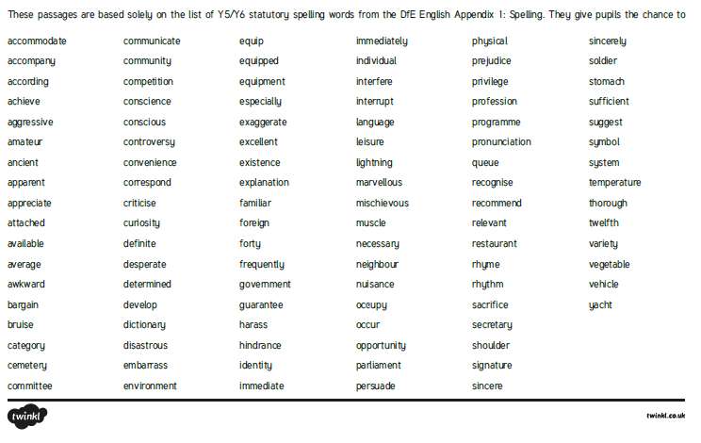

Tuesday April 28th April

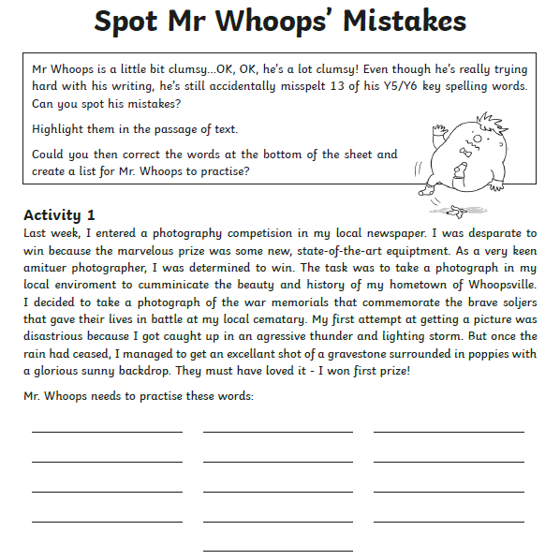
Thursday 30th April
