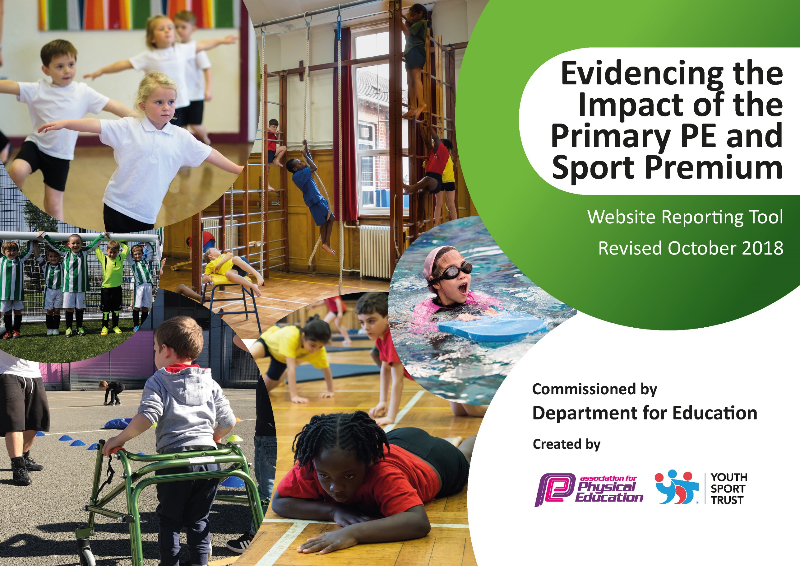
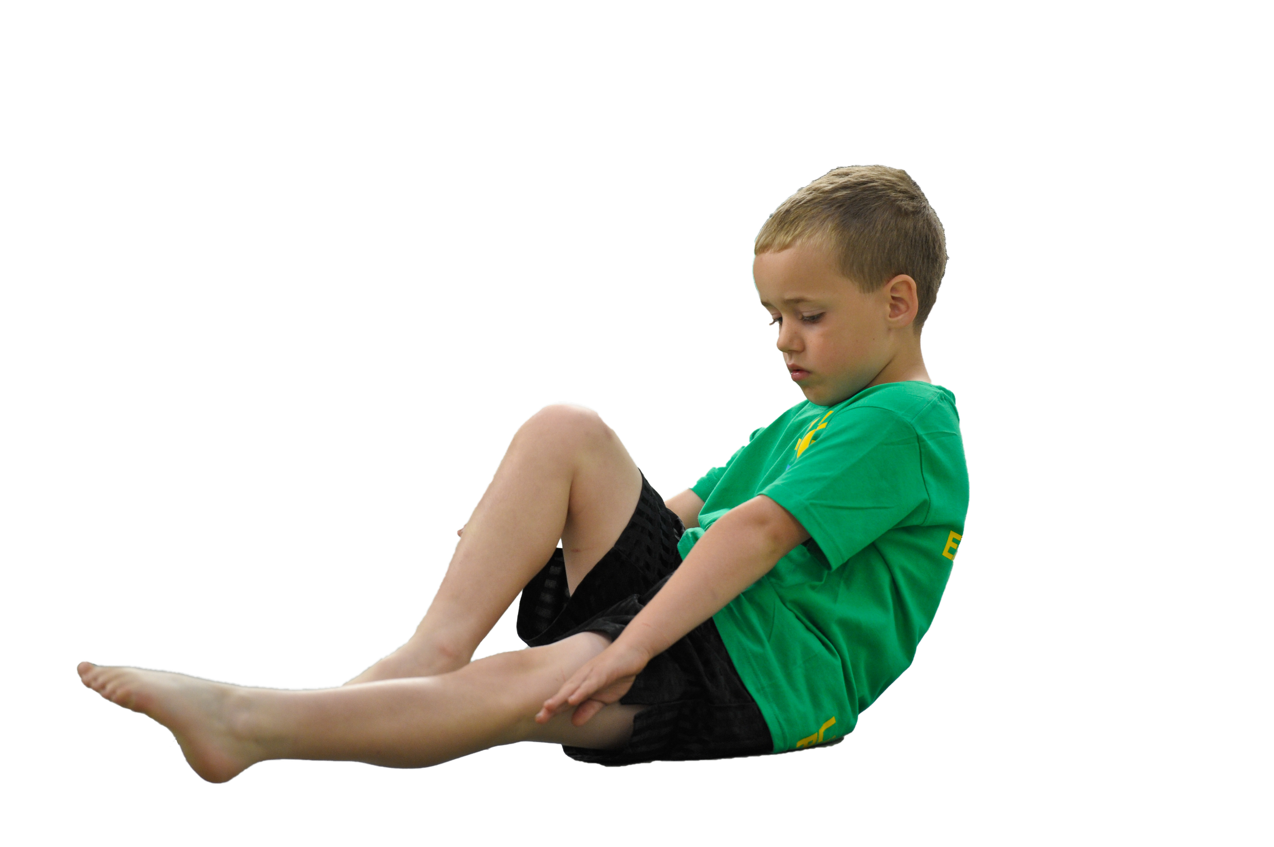
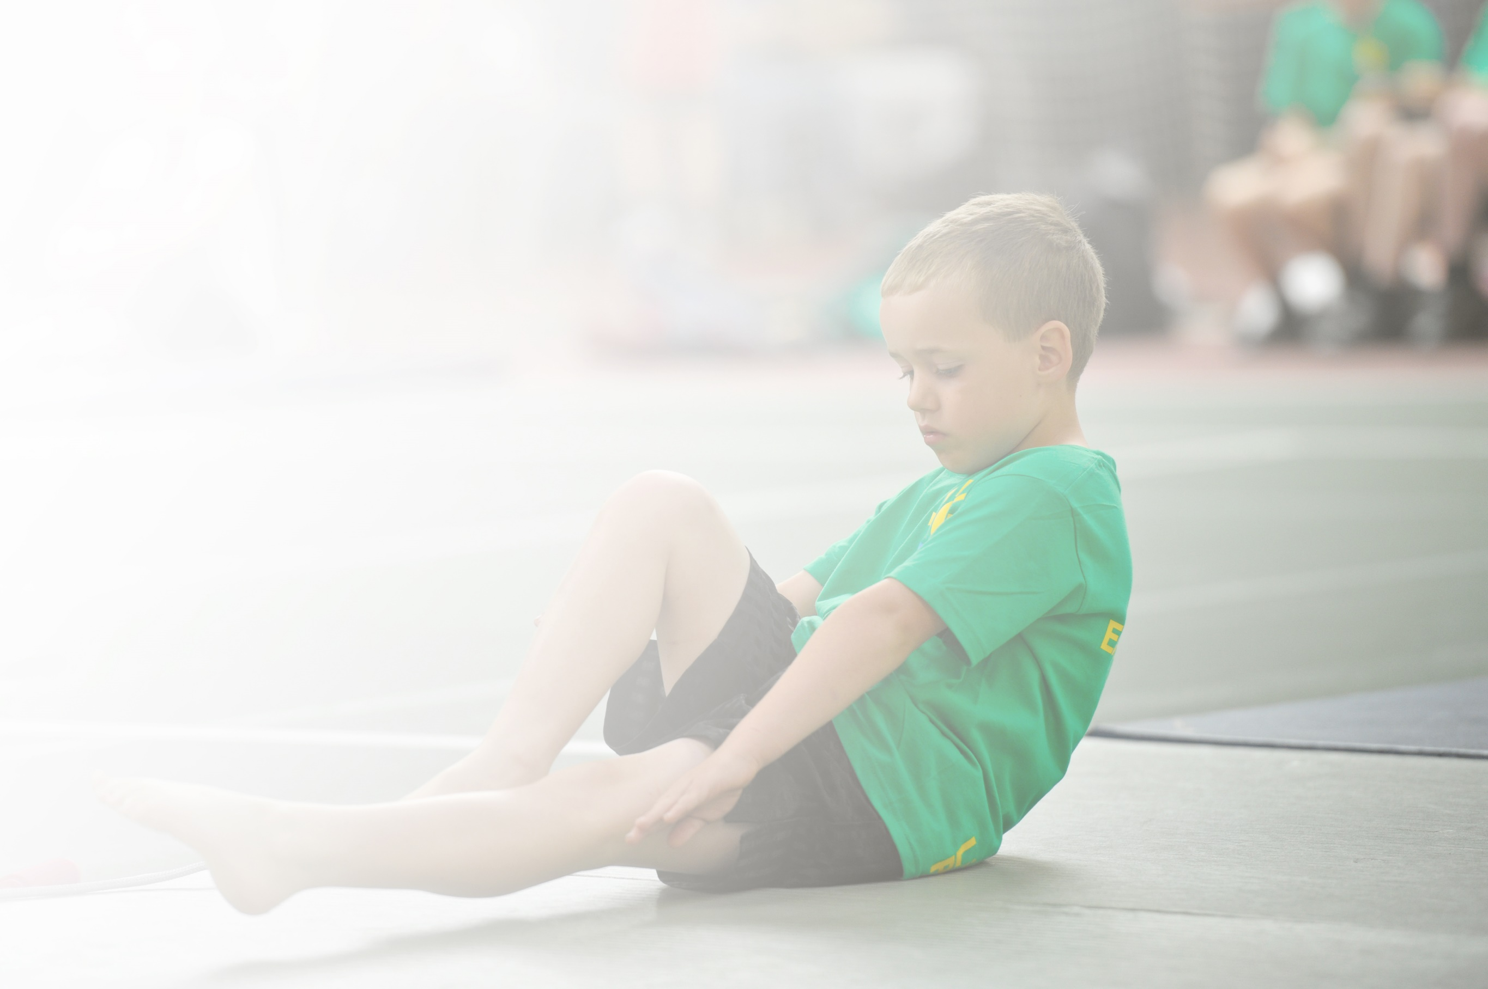
Schools must use the funding to make additional and sustainable improvements to the quality of Physical Education, Sport and Physical Activity (PESPA) they offer. This means that you should use the Primary PE and Sport Premium to:

- Develop or add to the PESPA activities that your school already offer
- Build capacity and capability within the school to ensure that improvements made now will benefit pupils joining the school in future years

Please visit gov.uk for the revised DfE guidance including the 5 key indicators across which schools should demonstrate an improvement. This document will help you to review your provision and to report
your spend. DfE encourages schools to use this template as an effective way of meeting the reporting requirements of the Primary PE and Sport Premium.

We recommend you start by reflecting on the impact of current provision and reviewing the previous
spend. Under the Ofsted Schools Inspection Framework, inspectors will assess how effectively leaders use the Primary PE and Sport Premium and measure its impact on outcomes for pupils, and how effectively governors hold them to account for this.

Schools are required to publish details of how they spend this funding as well as on the impact it has on pupils’ PE and sport participation and attainment by the end of the summer term or by 31 July 2019 at the
latest.
We recommend regularly updating the table and publishing it
on your website throughout the year, as evidence of your
ongoing review into how you are using the money to
secure maximum, sustainable impact. To see an
example of how to complete the table please
click HERE.

Support for review and reflection - considering the 5 key indicators from DfE, what development needs are a priority for your setting and your students now and why? Use the space below to reflect on previous spend, identify current need and priorities for the future.

Key achievements to date: | Areas for further improvement and baseline evidence of need:
Daily Mile introduced in all KS2 classes on all days with no PE lesson. Fitness improved as a result.  Continued high percentage of KS2 children involved in physically active clubs.  More children are physically active at break times.  More children are participating in competitive sports, including SEND children.  Ripponden J&I are extremely successful when they enter sports competitions and tournaments.  Due to COVID19, many plans have been put on hold until next year and it has not been possible to collect all necessary data. | Increase number of physically active clubs for KS1.  Provide more variety of physical activities at break times (for KS1 and KS2).  Continue to take part in the Daily Mile – encourage staff to motivate children and be role models. Aim to improve every child’s fitness over the year.  Introduce Daily Mile in KS1.

Meeting national curriculum requirements for swimming and water safety | Please complete all of the below:
What percentage of your current Year 6 cohort swim competently, confidently and proficiently over a distance of at least 25 metres?  N.B. Even though your children may swim in another year please report on their attainment on leaving  primary school. | 88%
What percentage of your current Year 6 cohort use a range of strokes effectively [for example, front crawl, backstroke and breaststroke]? | 88%
What percentage of your current Year 6 cohort perform safe self-rescue in different water-based situations? | 88%
Schools can choose to use the Primary PE and Sport Premium to provide additional provision for swimming but this must be for activity over and above the national curriculum requirements. Have you used it in this way? | No

Action Plan and Budget Tracking
Capture your intended annual spend against the 5 key indicators. Clarify the success criteria and evidence of impact that you intend to measure to evaluate for students today and for the future.

Academic Year: 2019/20 | Total fund allocated: £17,920 | Date Updated: 21.07.20
Key indicator 1: The engagement of all pupils in regular physical activity – Chief Medical Officer guidelines recommend that primary school children undertake at least 30 minutes of physical activity a day in school |  |  |  | Percentage of total allocation:
 |  |  |  | 19%
School focus with clarity on intended impact on pupils: | Actions to achieve: | Funding allocated: | Evidence and impact: | Sustainability and suggested next steps:
To increase the physical activity of children during playtimes and lunch breaks and also during lesson times/ assemblies where possible. | Sports leaders to lead playground activities for KS1 and encourage all to take part.  Provide sports equipment for playtimes.  All KS2 children to take part in the Daily Mile.  Repair/replace balance bikes and helmets.  Purchase outdoor sound system for use at playtimes. | £3,420 | Sports leaders report back on uptake of activities and suggest improvements/changes to increase participation.  More children engaged in sports activities at playtimes.  More children taking part in Monday Mile Club and more children ‘running’. | Next year’s sports leaders to be trained and devise new activities/order new equipment.  Monday mile club to be replaced with ‘Daily Mile’.
Key indicator 2: The profile of PESSPA being raised across the school as a tool for whole school improvement |  |  |  | Percentage of total allocation:
 |  |  |  | 22%
School focus with clarity on intended impact on pupils: | Actions to achieve: | Funding allocated: | Evidence and impact: | Sustainability and suggested next steps:
To raise the awareness of physical education and school sports by installing a path to enable the ‘all weather’ track to be accessed and used all year round. | New path to be installed for easier access to the ‘all weather’ track to enable all year ‘Daily Mile’. The whole school to be expected to use the track and use it to improve their personal fitness. | £4000 | All children aware of the project and took part in sponsored run to raise money. Daily Mile to start in September 2019. | All weather path to be used all year round and will be used for years to come.

Key indicator 3: Increased confidence, knowledge and skills of all staff in teaching PE and sport |  |  |  | Percentage of total allocation:
 |  |  |  | 17%
School focus with clarity on intended  impact on pupils: | Actions to achieve: | Funding  allocated: | Evidence and impact: | Sustainability and suggested  next steps:
To introduce online platform ‘Real PE – Jasmine’ to all staff for easier delivery of PE lessons. All teaching staff to receive training on how to use the platform and implement in 2020/21.  Also introduce Real Gym. | Purchase online platform and organise training.  Ensure equipment is available for staff to deliver the ‘Real PE’ Curriculum. Replace damaged equipment. | £3000 | Children’s progression of agility, balance and coordination through the ‘Real PE’ curriculum.  Staff more confident to deliver clubs. | Audit equipment to continue full and consistent use of Real PE scheme.  Continue to use coaches where appropriate.
Key indicator 4: Broader experience of a range of sports and activities offered to all pupils |  |  |  | Percentage of total allocation:
 |  |  |  | 20%
School focus with clarity on intended  impact on pupils: | Actions to achieve: | Funding  allocated: | Evidence and impact: | Sustainability and suggested  next steps:
To offer as wide a range of sports/physically active clubs as possible using time before and after school as well as at lunch times. | Use staff and coaches to provide as wide a range of extra-curricular clubs as possible.  Take children to sports activities provided for SEND children.  Purchase new gymnastics equipment (crash mat) | £3500 | More children participating in more physical activity.  SEND children engaging in and enjoying physical activities. | Continue to offer a wide range of physically active extra-curricular clubs.
Key indicator 5: Increased participation in competitive sport |  |  |  | Percentage of total allocation:
 |  |  |  | 22%
School focus with clarity on intended  impact on pupils: | Actions to achieve: | Funding  allocated: | Evidence and impact: | Sustainability and suggested  next steps:
To encourage and include as many children as possible in competitive sports both in and out of school. | To provide as many opportunities as possible for children to attend a wide range of competitive sports events. Join school sports partnership groups to allow this. Take B and C teams where possible.  Purchase new leotards for gymnastics competitions. | £4000 | A high percentage of children taking part and being successful at competitive events – look at the trophy cabinet! | Continue to participate in ‘family events’ in the local cluster as well as School Sports Games. Enter new events if possible.

