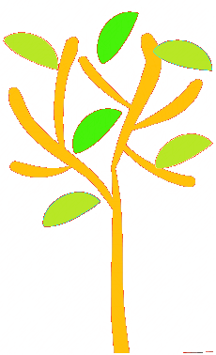

**Science**

**As scientists** we will be learning about animals (including humans) by describing their features and putting them into scientific groups. We will learn about our bodies and our senses. We will talk about pets and how to look after them. We will also be looking at the changes that take place in summer.

**Saplings**

**RSE/PHSE**

**As health and well-being experts** we will think about how can we look after each other and the world? We will relate this to friends, animals, the environment and older people. We will talk about moving to a new class. Our RSE content will link to science to name the body parts of boys and girls.

**Art and Design**

**As artists and design technologists** we will be looking at landscape in art. We will be inspired by the seaside and summer and use different media to create our masterpieces.

**PE and Games**

**As healthy exercisers** we will be studying REAL PE Unit 5 which involves ball skills, coordination and agility as well as the Daily Mile on the track. We will have a class sports day and whole school sports day in the last week of June. Please make sure your child has a ***named*** indoor PE kit (red top and black shorts) as well as ***named*** trainers. Red hoodies and black sweatpants or leggings can be used outside too.

Pumps are no longer required.

**English**

**As readers, writers and communicators** we will be reading stories about African animals and learning more about describing words (adjectives). This links our English topic to the study of animals in science. We will also investigate hedgehogs through non-fiction books and the internet. We will be learning Phase 5 sounds as well as learning suffixes ending in -er and -est We still change reading books once a week on **Fridays.** Try to read the books twice and ask questions about the story and the words or phrases that may be difficult for your child. Comprehension is just as important as decoding the words.

**Maths**

**As mathematicians** we will continue with place value to 50. We will count in 2s, 5s and 10s. Then we will then look at multiplication, division and fractions. We will continue to solve problems practically and in pictures. At home you can help your child by practising number formation from 20-50 and dividing up food or sharing out sweets. Paper based maths homework will be sent home weekly and there are games to play on Edshed.

**ICT**

**As information technologists** we will log onto Purple Mash and Edshed to play maths and spellings games.

**Summer term 2 2022**

**What do animals need and where do they live?**