Ripponden J&I School
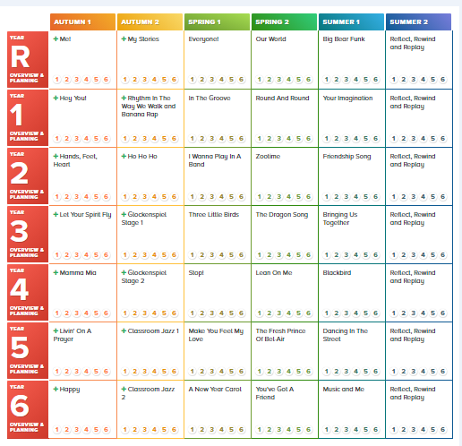
Music Long Term Plan in response to COVID-19
2020-2021

