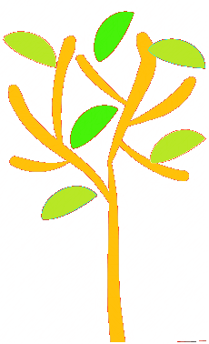

**Art and Design**

**As artists and design technologists** we will be looking at basic clay modelling. We will look at the sculptures of Joan Miro and Henry Moor, along with other sculptures on display at the Yorkshire Sculpture Park.

**Geography**

**As geographers** we will be looking at and making maps of our class and of our school. We will also start to learn about the differences in weather in the areas of the U.K., starting with the local weather. We will use Google maps to help us learn about Ripponden.

**RE/ PSHE/ RSE**

**As children of the world** we will continue to learn about relationships and feelings (PSHE/RSE) and special books and stories (RE).

**P.E**

**As health and well-being experts** we will be consolidating our balance and agility work this term. We will practise jumping and landing as well as balancing on a line. Please could you provide your child with a red top, black shorts & trainers. A hoodie and joggers are also needed as all our P.E is outdoors. Please could all P.E. and school wear be named, even pumps and trainers.

**Maths**

**As mathematicians** we will be learning more about number and place value. We are working on addition and subtraction in this half term. We will do our work very practically, record onto paper and try to move onto problem solving where there is not always just one answer! We will also focus on drawing pictures to represent numbers. Online Sumdog homework is set each week.

**English**

**As writers and communicators** we will be looking at the stories of Percy the Park Keeper. Our question for this term is, ‘What does Percy’s Park look like?’ What do you think? Answering this question will link our English with our science (seasons) and geography (maps) work. Our daily phonics class will focus on blending and segmenting to help us with our reading and we will be re-visiting Phase 3 and Phase 4 letters and sounds. We change your reading books on Mondays and Fridays. Start with discussing the pictures then always read your book twice! Spellings are set on Edshed each week. You can also upload your spellings to Google classroom if you wish.

**Music**

**As musicians** we will be appreciating songs from the hip –hop genre and learning how to sign happy birthday.

**Computing**

**As information technologists** we will use programmes which will help us create our own digital art work.

**Science**

**As scientists** we will look at changes that happen in autumn and make use of our fantastic back field to investigate these changes. We will learn about day light and how it changes over the year as well as naming all the seasons and the months of the year.

**Autumn term 2 2020**

**What does Percy’s Park look like?**

**Saplings**