MERRY CHRISTMAS FROM YOUR SCHOOL NURSING TEAM!

As the Christmas holidays approach, especially in such challenging times, I’m writing to remind your staff about ChatHealth, the NHS school nurse messaging service which is available to your pupils at your school. The service for young people in Calderdale is part of a unique, multi-award winning NHS scheme, which has been highly acclaimed by service users and NHS officials for improving access to healthcare.

You can send a text via ChatHealth for confidential and anonymous advice on all kinds of health issues, like emotional health, sexual health, bullying, healthy eating and any general health concerns.

The text number for this is:

Parents/carers: 07507332157

Young people: 07480635297

Or visit www.chathealth.nhs.uk to start a chat.

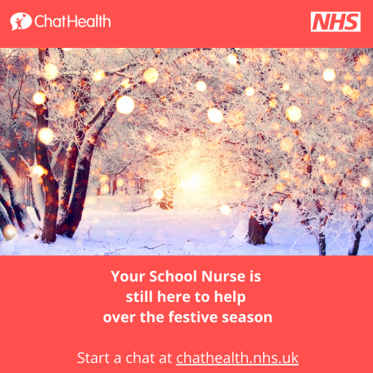 | We are still here to help, even during the Christmas holidays, our opening hours are:  9am-4.30pm Monday 21st December- Wednesday 23rd December 2020  9am until 2.30pm on 24th December 2020  Closed 25th December and 28th December 2020. 9am- 4.30pm 29th and 30th December 2020.  9am – 2.30pm on 31st December.  Closed 1st January  Open as normal from 4th January 2021.  We are happy to answer any questions  and welcome you to contact us.
