Busy Bees

Ripponden J&I School
Out of School Club

Information booklet &
Terms and Conditions
2019-2020

Welcome to Busy Bees

ABOUT THE CLUB
Busy Bees Out of School Club is based in the school grounds and is run and managed by Ripponden J&I School. The contact details are:

Address: Busy Bees – Ripponden Out of School Club
Ripponden J&I School
Halifax Road
Ripponden
Sowerby Bridge
HX6 4AH

Telephone: (01422) 823362 option 4 message service or option 3 if urgent.

Email: office@ripponden.calderdale.sch.uk

Who should I contact?
Invoices and payments: Mrs Smith in the school office
Attendance/bookings: Any member of Busy Bees staff or on the Facebook Page
Other queries: Any member of Busy Bees staff or Busy Bees Manager.

Our Aim
Our aim is to provide a safe, secure and relaxed environment, offering a range of exciting and varied activities for all ages, with a balance of planned activities as well as activities that reflect the interests of the children in our care. Many children enjoy playing outdoors in the school grounds or prefer some quiet time watching TV or playing with a range of games and toys. There will always be a selection of provision including dressing up, board games, construction, reading and computer games.

*Please note that DVDs are certificate U, or at the discretion of the coordinator PG (this will be based on the overall age group present at a particular session). Children are not allowed to bring in their own DVDs unless they comply with the above requirements and permission is sought from the coordinator in charge. Computer games will also be appropriate and relevant to the ages of the children.

Busy Bees enjoy a close working relationship with Ripponden J&I School in order to ensure continuity of care and to maintain effective communication channels. Most of the policies from school have transferred over to Busy Bees in order to maintain consistency. Most of the staff from Busy Bees also have roles in school during the day. As a result, we will be able to ensure consistent expectations through our Branch Out ethos.

STAFFING
Busy Bees is committed to safeguarding and promoting the welfare of children. To achieve our commitment, we will ensure continuous improvement and development of robust safeguarding processes and procedures that promote a culture of safeguarding amongst our staff.

All staff and volunteers are DBS checked and receive regular training in child protection issues. A minimum of one member of staff at any session will hold current a Paediatric First Aid Certificate.
James Haigh  Coordinator | Josie Blair  Play worker | Andrea Whiteley  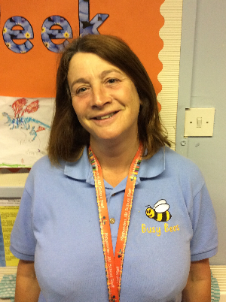  Play worker | Lizzie Greenwood  Play worker
SEN/Inclusion, Health & Safety, First Aid coordinator, Fire Safety, planning/provision. Work experience/volunteers. Staff and duty rotas | Coordinator cover. Child protection/safeguarding. Planning/provision. EYFS Key person. Journals. | Planning/Provision Journals | Planning/Provision Journals

Tracy Thompson  Play worker  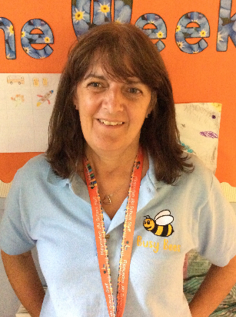 | Rosa Calcott  Play worker  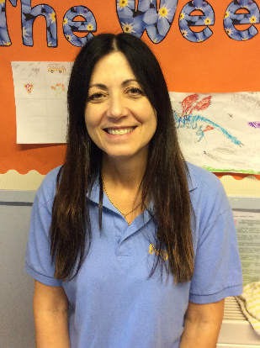 | Vicky Perrin  Play worker  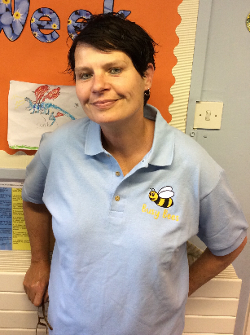 | Catherine Sagar  Play worker  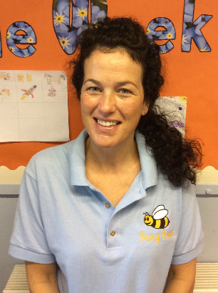
Planning/Provision Journals | Planning/Provision Journals | Planning/Provision Journals. Deputy DSL. | Planning/Provision Journals

Tracey Coneron  Relief/holiday play worker | Lorraine Bamforth  Headteacher | Sandra Smith  Administration Assistant
Planning/Provision Journals | Staff supervision & CPD  Safeguarding  Policies and procedures | Billing and invoicing queries
All staff have a duty of care to child protection and safeguarding and therefore, the right to take reasonable action to ensure the safety and welfare of pupils. All staff will follow the child protection and safeguarding procedures, policies and reporting of concerns provided by the school and Local Authority. There are three members of staff trained as Designated Safeguarding Leads (DSLs) – Miss Taylor is the DSL and Mrs Bamforth and Mrs Perrin are the deputy DSLs.

If you have any query or concern at any time, please speak to the coordinator in the first instance. If you prefer, please contact either Miss Taylor or Mrs Mrs Bamforth via the main school office.

Busy Bees Out of School Club is very flexible and reasonably priced. Children have a choice of breakfasts and after school snacks during term times. Pick up times can vary depending on parents’ schedules.

Our Out of School Club is a popular facility; therefore, places must be booked in advance to ensure we have the correct staffing levels to enable us to fulfil out safeguarding responsibilities.

Should you wish to visit the club, please telephone school to make arrangements. For security reasons, adults unknown to our staff are discouraged from calling into the club unannounced. Staff have a duty to protect the children in their care from strangers.

You and your child are welcome to visit the club before your child’s first day, to familiarise yourselves with the setting and to help your child settle in. During your child’s first session, time will be set aside for an induction. The induction will include running through the club’s rules and routines (including meal times, collection etc) and introducing your child to the staff and other children. Another child will usually be allocated to act as your child’s buddy for the first few sessions.

TO REGISTER
Parents wishing to use Busy Bees OOSC are asked to carefully read the information and terms and conditions in this booklet. Key points of the main policies are included in this handbook and copies of the full policies are kept in school and are available for parents to consult if necessary.

Terms and conditions are reviewed annually. There may be occasions when changes to terms and conditions occur prior to annual review and parents will be notified of these in writing and asked to sign and return an acknowledgement.

Our club aims to be accessible to children and families from all sections of our local community. Admission to the club is organised by the coordinator and we use a waiting list system when the need arises. This will be on a first-come, first-served basis, with the exception of siblings who have priority for the same days as a sibling already attending. As school have taken over the management of Busy Bees, it is highly unusual that we are unable to admit children, as we are able to staff the club accordingly.

We require a set of registration forms for your child before they can attend the club (available from the coordinator). This information will be treated as confidential and will be stored appropriately.

OPENING TIME – with effect from September 2019

TERM TIME:
The morning session is open from 7.30am until 9am
The afternoon session is open from 3pm until 6pm.
Children are provided with a choice of breakfast and afternoon snack. The food that we provide at the club is not intended to be a substitute for a main evening meal, but we do provide healthy snacks, including fresh fruit and vegetables, as well as a ‘fun tea’ once a week. We use fresh ingredients and fresh drinking water is available at all times. We can meet any individual dietary requirements; therefore, please inform the club should your child have any food allergies.

SCHOOL HOLIDAYS:
During the school holidays, the Holiday Club runs from 8am until 6pm.

FEES – with effect from September 2019
Fees are reviewed annually and any increase (if applicable) is with effect from September each year. Parents will be given advance notice of rate changes.

TERM TIME: | FIRST CHILD | ADDITIONAL SIBLINGS
Morning session (7.30-9am) | £4.50 | £4.00
Afternoon session (3-6pm) | £7.00 | £6.50
*During term time, breakfast is provided, along with an after-school snack.

SCHOOL HOLIDAYS: | FIRST CHILD | ADDITIONAL SIBLINGS
Half day (8am-1pm or 1pm-6pm) | £11.00 | £10.00
Full day (8am – 6pm) | £22.00 | £20.00
*During the school holidays, children required to bring a packed lunch. Breakfast is provided along with mid-morning and mid-afternoon snacks.

BOOKINGS, INVOICING AND PAYMENTS

- Term Time Out of School Club
- Bookings must be made at least a half term in advance via the club.

- Longer term bookings i.e. for the whole year, can also be made.

- Once a place has been secured, confirmation will be issued along with a summary of payments required for the sessions booked, detailing monthly amounts to be paid.

- Payments can be made using our online payment system, by standing order, cheques or childcare vouchers. Cheques are payable to Ripponden J&I School.

Bank details: Lloyds Bank PLC

Account number: 69926268

Sort Code: 30-93-76

Account Name: Ripponden Junior & Infants School

Please ensure you put your child’s name (and class if possible) as a reference.

- Once places are booked, they may not be cancelled (except in exceptional circumstances, which have to be negotiated with the school at the time and the school would require at least a half-term’s notice).

- Due to staffing costs, there will be no refunds for absence due to sickness, unless again negotiated with management.

- There will be no refunds made for non-attendance, unless previously agreed with the school due to exceptional circumstances, this includes non-attendance due to the participation in other extra-curricular activities.

- If the school or club is forced to close for any unforeseen circumstances e.g. boiler breakdown, adverse weather, no refunds will be made for the first day of closure.

- If monthly payments are not made (or a payment plan agreed), places will be withdrawn.

- Ad hoc bookings or changes to bookings may be made if the club can accommodate your child. If this is the case, please contact the school or club and you will be notified if this is possible.

- Late collection charge: If you fail to collect your child/children at a specified time, we will have to pay our staff to stay late, therefore a charge for late collection will be invoiced. This will be £10.00 for up to 15 minutes after collection time and £10.00 for every 15 minutes thereafter. If repeated late collection occurs, then places at the club will be withdrawn. To minimise any upset from your child/children, please telephone the club to advise that you will be late.

- Management of debt: For debts less than £250 – if agreed payments are not made, the school will seek to:

- Arrange a meeting with the School Business Manager or Headteacher and parents to discuss the issue;
- Set up a payment plan;
- Monitor payments regularly;
- If payments are not made as agreed, places at the club will be withdrawn.

If debts continue to be unpaid, the school will pursue the outstanding debt through the small claims court.

- Holiday Club
- The yearly overview of opening time commitments will be issued to parents in advance and subject to demand.
- Booking forms will be issued at the beginning of every half term for the following school holiday.
- Once a place has been secured, confirmation will be issued along with a summary of payments required for the sessions booked.

- Additional information
- Under no circumstances should parents use the school car park when dropping off or collecting children.
- Staff will ensure full supervision of children at all times.
- The following outside areas of the school premises are also available to the club: the school playground and equipment and the school field (weather permitting)
- Activities vary from day to day depending upon the age group of the children and whether they are to play indoors or outdoors.

THE AGREEMENT – to be signed and returned to the club

BUSY BEES OUT OF SCHOOL CLUB AGREES TO:
- Provide a safe and stimulating environment where children and parents are valued, ensuing confidentiality at all times.
- Ensure that all children are safety escorted to the club by members of staff (or later if they are attending an after-school activity club) and supervised at all times during club opening hours.
- Not allow any child to leave the club with anyone other than the parent/carer unless a form of identification or a password has been agreed between the staff and parent/carer.
- Notify the parent/carer if your child is showing signs of being unwell, making every attempt to contact one of the people listed on the Registration Form to arrange collection of your child.
- Deliver the Early Years Foundation Stage curriculum to Reception children so that all areas of development are supported.
- Provide a range of creative and stimulating play, recreational and educational opportunities, ensuring equality of opportunity in all activities.
- Provide breakfast and an afternoon snack for your child/children (children requiring breakfast must be on site before 8.25am)

PARENTS/CARERS AGREE TO:
- Support the ethos of the club and its work in after school childcare. This includes supporting the rules which are essential for the good behaviour, the safety and general welfare of all children in the club.
- Ensure the club is informed of any changes relating to the registration form e.g. address, home telephone number, mobile numbers and health needs etc.
- Make sure payments are made in advance upon receipt of the invoice.
- Provide 4 weeks notice of any cancellation of place.
- Discuss all matters concerning your child/children on Out of School procedures with staff, in a constructive manner.
- Only allow named adults as per your child/children’s record to collect your child/children. Any unnamed adult arriving to collect your child/children will not be allowed to collect your child/children.
- Encourage your child to act independently and to take responsibility for himself/herself and his/her belongings at the club.

PUPILS AGREE TO:
- Respect myself, all staff and other children and behave sensibly at all times.
- Be kind to others and share the equipment, always treating the equipment with respect.
- Follow our Branch Out values in Busy Bees as well as in school.
- Tell an adult if I have a problem.
- HAVE FUN!

I agree to the terms and conditions contained in this Information Booklet.

Signed: Print name:

Parent/carer of:

Date:

